MEMORANDUM OF AGREEMENT (MIP-NATO-MOA)

BETWEEN

MULTILATERAL INTEROPERABILITY PROGRAMME (MIP)

AND

NATO MILITARY COMMITTEE STANDARDIZATION BOARDS (MCSB)

AND

NATO COMMAND CONTROL AND CONSULTATION BOARD (C3B)



**xx XXX 2022, Mons, Belgium**

This MIP and NATO MOA has been reviewed and is hereby approved by the following organisations.

_____________________ _________________________ ______________________

MIP MSG Chairperson NATO MCSB Chairperson NATO C3 Board Chairperson

TABLE OF CONTENTS

___________________________________________________________________________

SECTION TITLE PAGE

___________________________________________________________________________

1 PURPOSE 3

2 ORGANISATION AND RESPONSIBILITIES 4

2.1 MIP Organisation 4

2.2 NATO MCSB Organisation 6

2.3 MIP-NATO Management Board 7

2.4 Responsibilities 7

2.4.1 NATO 7

2.4.2 MIP 8

2.4.3 MIP-NATO Management Board 8

3 MIM as Contribution to the CXCSRM 10

3.1 Stakeholders 10

3.2 Definition 10

4 PROGRAMME OF WORK (POW) CXCSRM 11

4.1 CXCSRM v1.0 11

4.2 CXCSRM Future Versions 11

4.3 Workflow 11

5 MIP-IES 12

5.1 Stakeholders 12

5.2 Definition 12

6 PROGRAMME OF WORK (POW) MIP-IES 14

6.1 Current MIP-IES 14

6.2 MIP-IES Future Versions 14

6.3 Workflow 14

7 Meetings 14

8 Tools 14

9 MOA CHANGES 14

MIP – NATO MEMORANDUM OF AGREEMENT

# PURPOSE

This document describes the agreement between the Multilateral Interoperability Programme (MIP), the NATO Military Committee Standardization Boards (MCSB) and the NATO Command Control and Consultation (C3) Board communities with the aim of contributing, producing, sustaining and evolving NATO’s Common Cross-Community of Interest Semantic Reference Model (CXCSRM) to harmonize information exchange standards within NATO in the context of the NATO Core Data Framework (NCDF).

After producing the first major version of the CXCSRM this agreement needs to be reviewed.

# ORGANISATION AND RESPONSIBILITIES

## MIP Organisation

The aim of the MIP is to achieve international interoperability of Command and Control Information Systems (C2IS) at all levels from tactical to operational level, in order to support multinational (including NATO), combined and joint operations and the advancement of digitisation in the international arena.

The MIP consists of Full Members (nations only) and Associate Members (nation and non-nation entities).

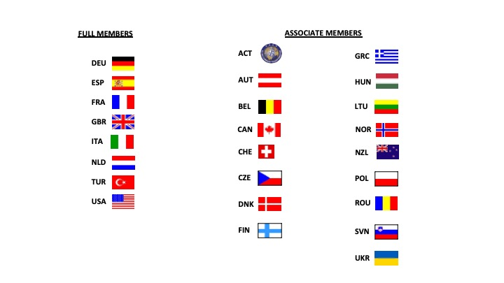

Figure 1 – MIP Nations

MIP is organised in the Integrated Project Team (IPT4), the Operational Staff Group (OSG), the Test and Validation (T&V) body and the MIP Information Model (MIM) Team with a Programme Management Group (PMG) and a high level MIP Steering Group (MSG) for resources, policy and targets.

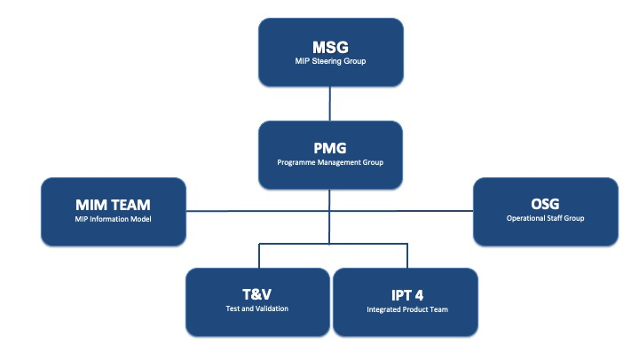

Figure 2 – MIP Organisation

The whole MIP organisation will be involved in the MIP-NATO relationship, however, the MIM team will be the main working group to produce and maintain the C2 Semantic Reference Model to be used by NATO CXCSRM and the MIP community. The OSG will also have a role in the coordination aspect of the IER (Information Exchange Requirements) with its different NATO counterparts.

The position of MIM team Deputy Chair[1] will be proposed to NATO. This position has to be present to all MIP working groups and should attend and report to the NATO MCJSB IERHWG and DM CaT meetings. The Deputy Chair position is foreseen until the first major version of the CXCSRM is created.

## NATO MCJSB Organisation

The Military Committee (MC) is the NATO Tasking Authority (TA) for operational standardization which encompasses all activities that affect interoperability across operating forces. The MC DTAs are the MC Joint Standardization Board (MCJSB), MC Land Standardization Board (MCLSB), MC Maritime Standardization Board (MCMSB), MC Air Standardization Board (MCASB), the MC Medical Standardization Board (MCMedSB), and the MC Terminology Board (MCTB). As per NATO Information Exchange requirement specification process the NATO C3 Board is responsible for the Implementation of agreed IERs. Within the C3B substructure, the NATO DM CaT is a multinational working group of the CIS Panel, responsible for the development and maintenance of NATO data management policies, the NCDF, and the CXCSRM for recommendation to the NATO C3 Board, together with guidance on the coherent implementation of data management and administration across NATO.

The IERHWG has the responsibility to harmonize IERs with and based upon the CXCSRM.

Figure 3 – MIP Organisation

## 2.3 MIP-NATO Harmonization Board

The MIP-NATO Harmonization Board (MNHB) will be established. Responsibilities are described in 2.4.3.

Both organisations will provide subject matter/operational experts as required to the working bodies of the substructure. If the resourcing of the substructure is not sufficient it will slow down the development process of the CXCSRM.

There will be one vote for MIP and one vote for NATO. If consensus cannot be achieved, an arbitration process will take place to bring all issues requiring resolution to the MSG, NC3B and MCSB if not resolved.

## Responsibilities

### NATO

#### The NATO DM CaT will

1. Represent the NC3B in MNHB meetings;
2. Perform high-level Data Administration;
3. Promulgate the MIM as a NATO STANAG and contribution to the CXCSRM;
4. Promulgate the MIP4 as MIP4-IES STANAG;
5. Perform configuration management and data quality processes of the CXCSRM;
6. Propose and prioritise any requirements for information exchange designated as Joint and/or Combined by a valid authority (NSA, SC, NATO DM CaT) for inclusion into MIM as it impacts the CXCSRM;
7. Promote semantic interoperability within NATO and to National C2 systems;
8. Standardize meta data (initially focussing on Data Elements[2]) from development of IERs to various mechanisms of information exchange;
9. Publish the MIP-IES and the MIM via the Information Resources Dictionary System (IRDS).
10. Provide the principle point of contact with NATO Standardisation Organisation (NSO);
11. Promote provision technical resources for the MIP to include the Joint and/or Combined IERs into the MIP-IES and MIM as required;
12. …

#### The NATO MCJSB IERHWG will

1. Represent the MCJSB in MNHB meetings
2. Coordinate and deconflict valid requirements with the MIP OSG;
3. Propose IERs for ‘Consultation’ for inclusion into the MIP-IES on behalf of NATO as required;
4. Promote provision of operational resources for the MIP to include the Joint and/or Combined IERs into the MIP-IES and MIM;
5. …

### 2.4.2 MIP

The MIP will:

1. Represent the MIP in MNHB meetings
2. Undertake modelling required for the evolution of the MIM as contribution to the CXCSRM incorporating approved IERs to include:
3. Design and control of the MIM model;
4. Implement agreed standards and procedures in the MIP-IES, in accordance with the OSG;
5. Maintain and control the MIP-IES development;
6. Provide resources to the MIM team and IPT, primarily focused on Land Centric requirements into the MIP-IES.
7. Provides a project plan with accountable resourcing. The project plan needs to be approved by MSG and considered into the MIP work plan.

### MIP-NATO Harmonization Board

The MNHB will perform, in combined NATO - MIP sessions held in conjunction with MIP PMG meetings, strategic planning consisting of:

1. Harmonization of IERs from NATO and MIP to incorporate into the first version of the CXCSRM as required.
2. Approval of MIM concepts/elements to incorporate into the first version of the CXCSRM.
3. Prioritising and de-conflicting IERs.
4. Approval of the Programme of Work for the evolution of the CXCSRM.
5. Resolution of any issue highlighted by either organisation.
6. Initial approval of the CXCSRM that both organisations will propose to their parent groups (NC3B, MCJSB and MSG) for final approval.
7. Is responsible for resourcing the MIM Team and the OSG with MIP and NATO expertise in accordance with the Program of work for CXCSRM.
8. Provides input to the MIP project planning.

# MIM as Contribution to the CXCSRM

## Stakeholders

NATO and MIP

## Responsibilities

For the MIM as a contribution to the CXCSRM and provider for initial CXCSRM concepts, the MIM team will:

1. Undertake modelling required for the evolution of the MIM as contribution to the CXCSRM,
2. Incorporate approved CPs to the MIM;
3. Provide support to other entities or Communities of Interest (COIs).

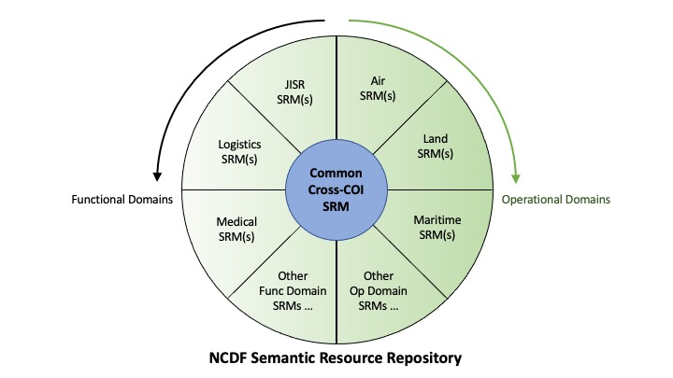

Figure 4 – NCDF Semantic Resource Repository

# PROGRAMME OF WORK (POW) CXCSRM

## CXCSRM v1.0

The first version of the CXCSRM will be developed after ratification of the NATO STANAG 5643 (“MIM”). This version will be based on common joint and/or combined concepts of the NATO STANAG 5643. The MIM team will propose the decision criteria for the rationalisation of the model to the MNHB for approval.

Other NATO prioritised outstanding COI requirements for the first version of the CXCSRM may include approved queue of Change Proposals (CPs), additional Air Tasking Order (ATO) features, Strategic Commands (SCs) or more to be managed as COI SRM’s. NATO provides the appropriate level of modelling and operational resources to complete the requirements.

## CXCSRM Future Versions

Operational and modelling requirements for future versions of the CXCSRM will be under NATO responsibility. It is proposed to include the MNHB in the approval process to make sure the CXCSRM and the MIM will stay harmonized along the process.

## Workflow

In principle, all communities will generate requirements. It is necessary to coordination between each other in order to deconflict requirements. The MNHB is asked to consolidate between MIM team and other relevant MIP or NATO bodies. NATO will provide adequate resources as NATO modelling team.

The MIM team will track new CXCSRM requirements and, in an iterative fashion, produce the necessary CP’s. The MIM team will report and liase with both the MNHB and the PMG, seeking guidance and clarification on resource, operational and technical issues respectively.

The MNHB will monitor the progress of the MIM team and other relevant MIP bodies and provide results to both MIP and NATO on a regular basis. Where the MNHB cannot resolve issues passed to it by MIP PMG, NATO DM CaT and MCJSB IERHWG, they will raise them to the next level (MSG, NC3B and MCJSB) for arbitration. Both communities will consult with both operational and external organisations as required.

These relationships are shown in Diagram 1 below.

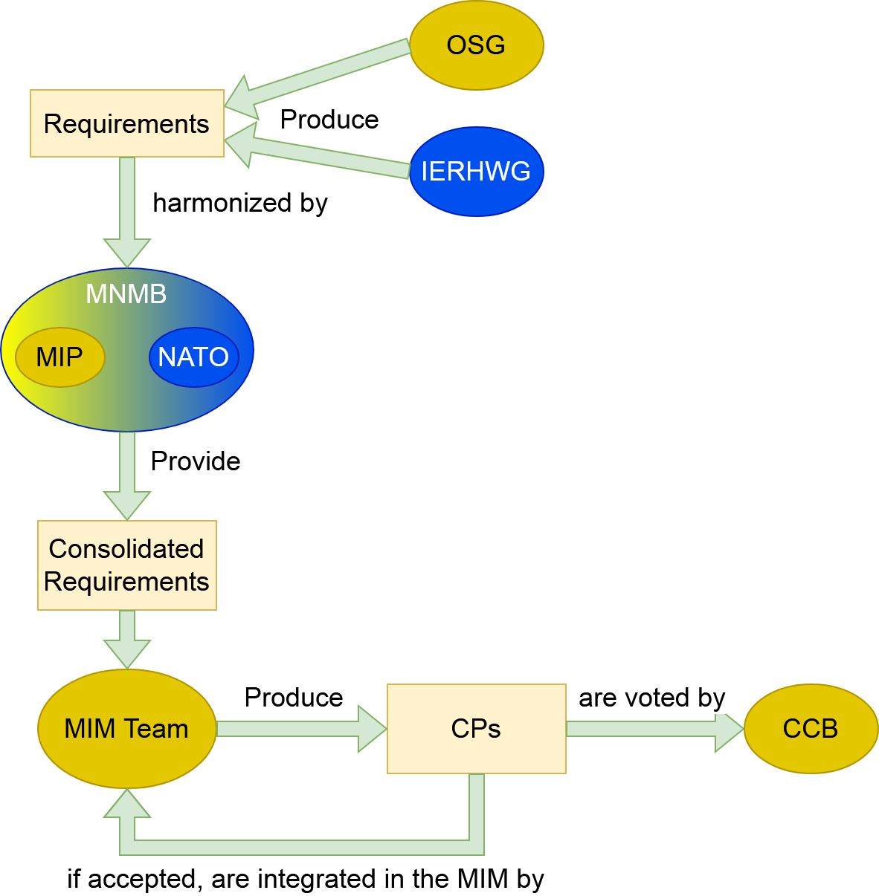

Figure 5 – Relationship between MIP - NATO

# MIP-IES

## Stakeholders

NATO and MIP.

## Definition

MIP-IES is characterized as follows:

1. Joint/Combined, that describes activities, operations, organisations in which elements of more than one Service and/or more than one Nation participate. [3]
2. Consultation, that implies the exchange of views and the conduct of deliberations amongst the highest authorities of the Alliance and member nations aiming at harmonizing positions and formulating recommendations on issues of common concern (consultation may involve international organizations, Partner nations and, as required, other non-NATO nations)[4].
3. Command and Control from the lowest appropriate level to the Strategic Commands Command and Control from the lowest appropriate level to the Strategic Commands requirements. Joint aspects from J1-J9 could be limited to the identified Commander’s Critical Information Requirements (CCIRs)[5].

d. Information Exchange Specification, which is a formal specification of information exchange between collaborating parties within a business area[6].

# PROGRAMME OF WORK (POW) MIP-IES

## Current MIP-IES

The current version of the MIP-IES is v4.3. It is foreseen to develop a new subversion every 2 years based on the MIP work plan.

## MIP-IES Future Versions

Operational and modelling requirements for further versions of the MIP-IES will be proposed by MIP. NATO and other bodies/COI may propose additional requirements.

## Workflow

New joint/combined requirements for the upcoming versions of the MIP-IES from NATO or other COI will be proposed by MNHB to PMG. PMG will take them into account and coordinate with OSG, IPT4 and the MIM Team to make an ICED proposal to MSG to be included in the MIP work plan for future development after MSG approval.

# Meetings

The MNHB will meet in conjunction with the MIP PMG. At the beginning of each MIP cycle they will approve both the IERs that are to be modelled in the next version of the MIM-impacted parts of CXCSRM and MIP-IES and the POW. It will meet at any time that is deemed appropriate, at the request of either party.

MIP and its substructure will meet at least four times a year. Other meetings may be held as required and could be hosted by NATO. It is mandatory for NATO to be represented at all MIP meetings and MIP shall be represented as appropriate at additional meetings hosted by NATO.

# Tools

For CXCSRM, MIP will provide the use of all needed MIP developed tools to NATO.

For MIP-IES, MIP will use the FMN agreed information exchange mechanism for XML based information as long as there are at least three NATO nations with implementations.

# MOA/MOU CHANGES

This agreement can be modified or amended at any time with mutual agreement of signing parties. It can be terminated by either party with at least 6 months written notice by the Chairpersons or designated representatives.

This agreement will be updated every two years after signature.

1. NATO will send additional recourses (modelling and operational expertise) as NATO representatives to the MIM team and the OSG.
2. Elaborated in ISO 11179.
3. Adapted from AAP 6 (2003).
4. AAP 6 (2003). From a Data Modelling prospective, this should allow the Commanders to participate in Consultation. To that end, the current C2IEDM and the Reference Model already include elements such as Rules of Engagement and Candidate Target List.
5. CCIR, in this context, is used to reflect the Joint and multi-Service Commander’s critical information needs. Further analysis is required on NATO’s methods for capturing these requirements.
6. From ATCCIS WP 3-7